Year 10
Unit 1- Introduction to IGCSE Global Perspectives

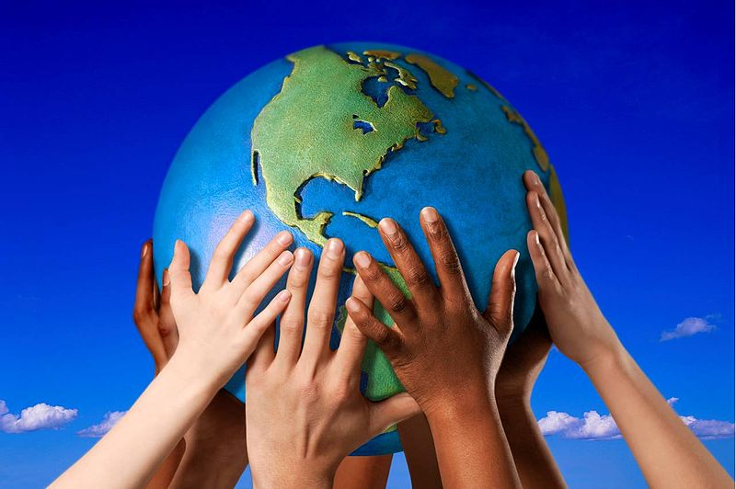

Student Workbook

Name: Isaac Chan

Introduction to the course

This 8-week introduction aims to introduce you to some of the key concepts and skills in the Cambridge IGCSE Global Perspectives course.

Global Perspectives is a course in which you will engage with a variety of global issues and seek to try and understand different perspectives, to develop your information literacy and critical thinking skills, as well as your ability to collaborate and lead in taking action on global issues.

Component 1: Written Examination – 35%  Component 2: Individual Research Report – 30%  Component 3: Team Project – 35% | 

Link to complete IGCSE Syllabus

Lesson 1- Introduction to Global Perspectives

What are the most serious issues for humanity?- ranking and justification

Food and Water Security
Climate Change

Health Pandemic

Deforestation
Crime
Religious Conflicts
Gender Inequality
Poverty
Racism

RELIGIOUS CONFLICTS | POVERTY | DEFORESTATION
CRIME | CLIMATE CHANGE | GENDER INEQUALITY
HEALTH PANDEMIC | RACISM | FOOD AND WATER SECURITY

Which issue is the most significant? And why?

Food and water is the most significant issue because they are requirements for human life and health.

Gallery Walk Activity

Look at the 8 images around the classroom that relate to one of the global perspectives topics. Which topic does it link to?

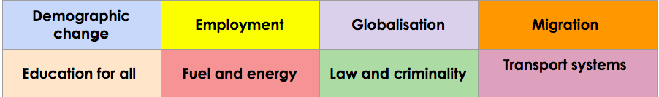

Photo | What does it show? Where is it? | Which of the 8 Exam topics does it link to?
1 | It shows a slightly fat guy on a bed reading a book in his bedroom | Law and Criminality
2 | A guy next to the tree | Employment
3 | A women with a piece of cloth on her head and says “I tell my stort because it is unique…” | Demographic change
4 | A lot of people protesing | Migration
5 | A photo of a lot of cars | Transport system
6 | 4 mans sitting on a chair chatting | Globalisation
7 | A photo of McDonald's has a clown next to it | Migration
8 | A white beard guy and black beard guy taking a photo of a truck | Fuel and Energy

Watch this video about the importance of the UN's Sustainable Development Goals for homework

Lesson 2 - Sustainable Development Goals ( SDGs)

The United Nations has outlined 17 goals - a blueprint or the “ultimate to do list” for the future of the planet.

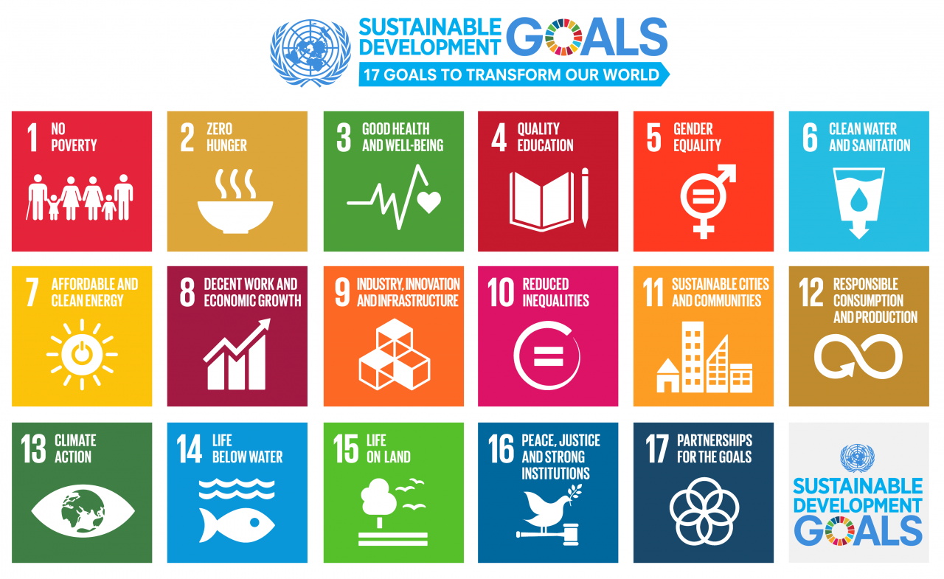

Watch this Video Introducing the UN - SDGs link

Consider one of the sustainable development goals - from this website

1. Identify an SDG that your group is interested in?
Life below water

2. Describe a solution that is being done at the local level (in a country) somewhere in the world?
On a local level, you can make a difference by making ocean-friendly choices when buying products or seafood, consuming only what you need, and actively reducing your use of single-use plastics.
3. Explain how this scheme helps solve this issue?
Establishing a legally backed, metric-driven framework that binds nations to target the root causes of ocean destruction

4. What can different stakeholders do to take action on this, and what can they do?
Governments pass laws and ban plastic waste.

5. Which of the SDGs do you think is hardest to solve? Why?
1, because functions as the ultimate "downstream" consequence of all other societal failures

Stakeholders in solving the SDGs

Various groups can tackle issues at the local and global level.
Task: Match the following stakeholders in achieving the SDGs to their roles:( use colour codes)

stakeholders | What can they do to support the goals?
Community Groups | An organisation at the local level that encourages people to join together to tackle a problem in the community. Eg residents associations
World Bank | This organisation provides funding for governments who need to borrow money to help achieve goals.
United Nations | A global body who have an oversight of development for all countries and who created the SDGs
Individual citizens | As consumers and as part of civil society, these people are at the local level and can influence local decision makers
Non Governmental Organisations | Organisations providing funding and project management in locations around the world at the local, national and global eg Greenpeace
Businesses | Through making and selling goods and services they have the ability to influence the SDGs through the way they operate.
National governments | Attempt to implement and manage development policies within countries at the national level. Eg UK government.

What are the barriers to achieving global goals?

In your groups think about the factors that can prevent Global Goals from being achieved

What are the barriers or problems that can prevent progress in SDGs? Record some examples below from your group/class and post it as a flurry task. Share with the class.

Lack of funding
Conflicts
Inequality
Runway pollution
Overfishing
Bycatch
Single use plastic trap animals

Lesson 3- Investigating a Debatable Questions

You will undertake a research investigation in one of the following issues. These will be selected for each group using a random group picker.

You will work in a team of 3 or 4 to answer one of the following debatable questions working towards the common assessment task for this unit over the next few weeks. Teams will be allocated a question using a random name picker or by your teacher.

Debatable Research Questions examples

Change in Culture and Communities- This House believes that race and ethnicity, not merit, determine career success.
Employment- This House believes machines taking over jobs does more harm than good in poorer countries.
Globalisation - This House believes that globalisation is destroying unique local cultures.
Migration and urbanisation - This House believes that host nations should view mass migration as a threat, not an opportunity.
Education for all - This House believes that educating women is the single most important factor in a nation's development.
Climate change, energy and resources - This House believes that the environmental cost of transitioning to renewable energy is too high.
Law and criminality -This House believes that punishing criminals is more important than rehabilitating them.
Transport, travel and tourism - This House believes that we should never trust AI to drive our vehicles.

What do you already know about this issue?

As a team Create a Padlet/Bubblus or other mind map tool to show what your team know about this issue already- what are the causes and consequences of this issue- where is it a problem? what different perspectives exist on this issue?

Paste a screenshot of your PADLET/MIND MAP in the table below or copy and paste your mind map. Discuss your question with your class/teacher. How do you interpret this question and how you might answer it?

Research and resources

You can use some of these resources to get you started but you should also independently research your debatable question.

CHANGING CULTURES AND COMMUNITIES | EMPLOYMENT | GLOBALISATION | MIGRATION AND URBANISATION
Video  Article  Article  Article  Article | Article  Article  Article | Video  Article  Article  article | Video  Article  Article  Article
EDUCATION FOR ALL | CLIMATE CHANGE ENERGY AND RESOURCES | LAW AND CRIMINALITY | TRANSPORT, TRAVEL, AND TOURISM
Video  Article  Article  Article | Video  Article  Article  Article | Video  Video  Article  Article  Article | Video  Video  Article  Article  Article  Article

Lesson 4 - Causes and consequences
Using the resources above and your own research describe and explain what is happening in your issue at the local/ national and global level.
Local/National | - things that are caused or happen in a specific place/ ie a town or a city- social economic political environmental- air pollution in a city/country
Global | - things that are caused or happen at a global level- social economic political environmental- eg global warming

Local- Cause and consequence
What's happening:

cause | consequence

National- cause and consequences
What's happening:

cause | consequence

Global -cause and consequence
What's happening

cause | consequence

How do we measure the significance of an event or issue?



- IMPORTANT: People at the time thought it was important.
- PEOPLE: It affected a lot of people.
- EVENTS: It led to other important events.
- ATTITUDES: It changed people's attitudes or the way they lived.
- TIME: It affected people for a long time.
What are the most significant consequences and why?

Most significant cause and why? | Most significant consequence and why?

Lesson 5 - Global perspectives survey- Values and perspectives

How do your views and values compare to other people in the world (UK)?  Complete the survey on this link and see how your views compare at the end of the survey. | 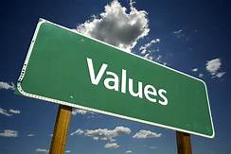

What influences our perspectives?

Our perspectives on the world are influenced by a variety of factors. Many factors can make up our perspectives and influence our view of the world.
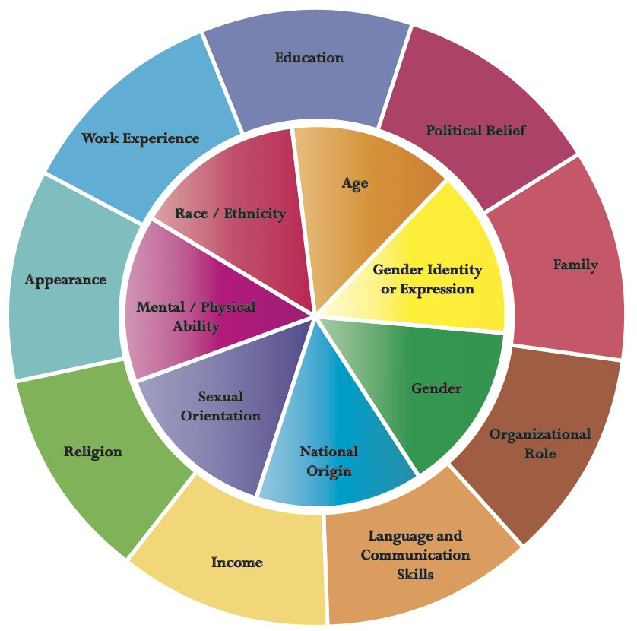

Give examples of how 3 of these factors could influence someone's opinions about your chosen issue ( debatable question):

Complete your own Identity wheel - Edit this diagram to outline your own identity wheel

RACE
ETHNICiTY
RELIGION
CLASS
EDUCATION/ ABILITY
NATIONALITY
LANGUAGE
AGE

How might a feature of your identity influence your perspectives on your chosen issue/ debatable question?

Lesson 6 - Contrasting Perspectives

Identify and describe at least 2 contrasting views on this issue for your debatable question?

- Find a picture and /or names of specific people connected to this issue/experts/stakeholders
- Describe what their views/perspectives are on the issue?
- Quote what they have said about this issue
- Why might they think this? Who has the most convincing argument?

Who?  Photo | What’s their perspective? | Quote/Evidence | Why do they think this?

What makes an argument or a view more convincing?



Think about the following factors- discuss this as a group and class - - are there any examples of this in the research you have done so far?

Write 2 or 3 examples in the space below.

Language | Evidence | tone
Reasoning | Clarity of argument | structure/balance

Lesson 7 - Information Literacy

Critical Thinking is a key skill in Global Perspectives. Being able to research and interpret different sources of information is a vital skill in Explorations. Below is some important vocabulary which is important to consider when researching and evaluating information. ( THIS IS REQUIRED FOR THE EXAM)

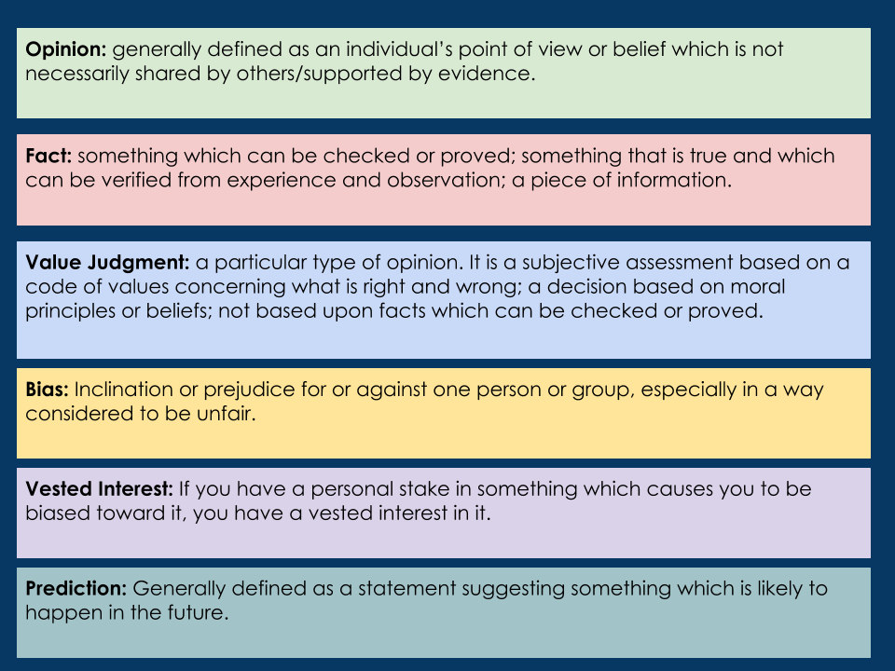

Can you find an example of 3 of these in your sources - use the Diigo chrome extension to annotate in the sources you have collected.- quote them in the table below.

 | evidence | Why this is | Source link
OPINION
FACT
PREDICTION

Lesson 8

In this session you will complete a CRAAP test for 2 contrasting sources of Information that you have used in your research so far.

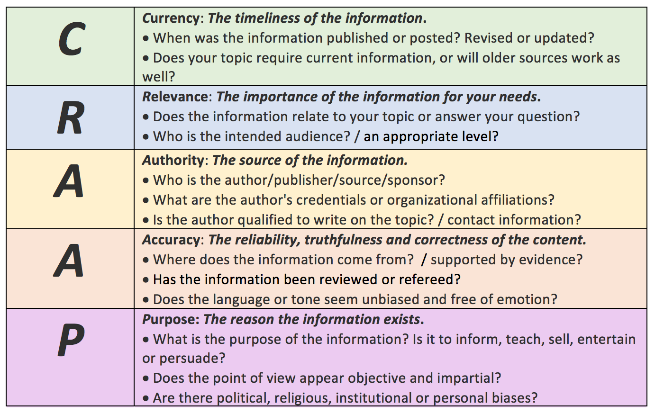

Source | CRAAP analysis
1

2

Lesson 9 - Courses of Action- Critical Thinking

 | Courses of action are potential strategies or things that can be done by different stakeholders to tackle problems or issues. - governments, business, communities etc  In Global perspectives for many issues in your exam the IRR essay or team project you will need to assess /evaluate different courses of action. These are things that have been already tried by different stakeholders to solve a problem.

 | Here is an example of 2 ways in which governments of countries approach the way that criminals are treated.  Watch the 2 videos about the ways in which countries like Norway and Singapore punish crimes.

 | Norway | Singapore
Describe the approach to the punishment of crime.
Strength
Weaknesses
Barrier/would this apply to other countries- if not why not?

For your own debatable question/ issue- outline 2 potential courses of action that have been tried to solve this problem in other places.

Course of Action 1

What is the course of action- Describe it?
Who has attempted this- government NGO, business, community etc...
Where has this been tried?
What are the strengths of this course in solving the problem
What are the weaknesses of this course in solving?
Would this course of action be successful in all countries, if not why not?
What might be a barrier to this being successful in another place?

Course of Action 2

What is the course of action- Describe it?
Who has attempted this- government NGO, business, community
Where has this been tried?
What are the strengths of this course in solving the problem
What are the weaknesses of this course in solving?
Would this course of action be successful in all countries if not why not?
What might be a barrier to this being successful in another place?

Personal perspective

In your teams you should consider what you think about your chosen issue. You should outline what you believe and why you think what you think- you might be able to refer back to key piece of evidence that have shaped your belief.

You should try to refer back to your original research question and attempt to conclude.

You can also conclude what you think should be done to solve the issue in the future

Lesson 10 and 11 - preparing for your presentation

Create a presentation with a selection of relevant images to support each section of your presentation:

- Preparing for your presentation
- Student Slideshow template
- Speech template

Prepare your presentation for next week- consider these resources to help you develop ideas for teams’ speech- each member of the team will deliver a different part of the presentation- this should be evenly divided between team members.

Good versus bad presentations video

Body Language in a presentation video

How to speak so that people want to listen video

Lesson 12 - Presentations

In todays lesson each group will report back to the class and will give the presentations for your chosen issue. Each member of the Team will be responsible for delivering an equal part of the presentation.

At the end of the lesson your class will give a score using the assessment criteria using a copy of a class google form that your teacher will share with you.

Give each of the teams a score out of 7 for both criteria.

Assessment criteria

 | Critical thinking | Communication | Positive Feedback comment
Team 1
Team 2
Team 3
Team 4
Team 5
Team 6
Team 7
Team 8

 | End of unit Reflection

Submit your final presentation and script to Toddle the summative assessment (SA) and link it to your Year 10 Student Booklet - Introduction to Global Perspectives 2025/2026

Paste these reflections about your learning in this unit to consider the following guiding questions:

1. What skills and knowledge have you learnt in this unit?
2. What have you enjoyed or done well in this unit?
3. What could you have improved on in this unit- critical thinking skills or communication?
4. Can you use your slides or speech template for evidence of your growth in these areas ?

News Presentation below in Term 3
Global and local issues- News analysis

What is going on in the world? As students of Global Perspectives we want you to take an interest in important issues and work towards understanding different perspectives on globally important issues..

 | During the first unit your group will be asked to report back on a NEWS REPORT - each team of 2-3 will report back on a news story-global or local. For between 1 to 2 minutes.  Your team will just do this once in this uni. Each member of the team should speak and you should include the following content:

- Some Visual- 2/ 3 photographs/headline
- What's the issue /problem?- description of the story/issue
- Who are the key stakeholders? (people affected/ involved in the issue)
- Why are you concerned? Why is this important to you/and us?
- Why should we care?

As a class try to choose different themed articles - your teacher may guide you on this

Here are a range of news links as well as physical newspapers. Link your groups news presentation slides in the space below



